A
Synopsis
On


Home Automation System Using Android Mobile Phone
Mini Project
For
Partial fulfillment of
Btech Computer Science in Engineering
Session (2020-21)

Submitted By:
Pushpraj Singh(191599015)
Mohit Sharma (191599011)
Abhishek Tomar (181500030)
Jaidev Singh (191599006)

Submitted To:

Mr. Mohd. Amir Khan

Technical Trainer

Department of Computer Engineering & Applications

Contents

Abstract |  | 3
1. | Introduction | 3
 | 1.1 General Introduction to the topic | 3
 | 1.2 Hardware and Software Requirements | 4
2. | Objectives | 4
3. Implementation Details |  | 4
4. | Progress till Date & The Remaining work | 5
5. | Some Screenshots | 6

Abstract

Technologies taken most part of human lives for optimizing day to day chores and monitoring surrounding to facilitate all services for maintaining daily routine. From time to time with upcoming generations has become a magnet for innovative ideas that leverage technology to solve society’s problem efficiently and effectively. In the era of information technology, from top to bottom humans are surrounded by numerous digital prototypes having potential to make their lives cumbersome to operate each appliance having its own control or remote control. Humans always feel to operate all home appliances remotely with single control system when he is away from his own native place. This paper presents a generic system for the proposed appliances control system describing the underlying design and implementation process. This paper also presents concrete guidelines for future researchers, academia and industry as well as for government to follow in developing a practical sustainable smart home appliances control system that has the potential to bring significant personal, professional and economic benefits to nation growth. We still face many challenges and hurdles in acceptance of these services. This paper also forecast the key future challenges associated with development and acceptance of the domain.

Index Terms—Smart Home Automation, Internet of Things (IOT), Control System, Bluetooth, Smart Things

Introduction

Humans need an interface to interact with every things and controller to control the working of device so as to effectively manage the process which positively affect environment and helps to produce the desired output which results in completion of user and machine goal. An interface allows creating both configurations for the controller and creative user interaction design module and control panels that allows to interact with devices and to control them. Controller manages runtime integration between devices and schedule various critical situation so as to not contradict with the functioning of devices.
Things are everything which surrounds human and all those device/appliances which are directly or indirectly playing important role in making life easier by helping in daily activities so as to refine the life style. Some of the appliances such as washing machines, music system, washers, freeze, air conditioner, bike, bicycle, television, fan, light, surveillance camera, utility meters, thermostats, water motor, shower, dryers, printer, car, smart phones, computers, wearable electronics and door lock-unlock etc. Fig. 1 shows different smart things/devices which are easily available in every home environment.

Things/appliances may act as smart things-devices due to their persisting working culture in response to the human action. Devices collective intelligence in collaboration with other devices in surroundings makes them smart enough to interact with controller to receive and transmit data signals to achieve common goal while executing particular action on the behalf of individual operating condition for performing remote sensing actuating and monitoring.

1.3 Hardware Requirements

- Arduino UNO
- Bluetooth Module
- Arduino cable
- 4-channel relay
- Breadboard

1.3 Software requirements

- MIT App Inventor

- Arduino

Objective

We make a system through which we can control appliances of our home and operate them easily. We face many problems in society as physically challenged people, old people have problem to operate their device such as ON/OFF the lights, fans etc. Sometimes some appliances remain ON by mistake so it increases the charge of bill. So, this system is very useful for these types of problems.

Implementation Details

Moreover implementation of wireless Bluetooth connection in control board allows the system to install in more simple way. The control board is directly installed beside the electrical switches where switches are controlled by relay. Here Arduino works as intermediate to operate appliances via relay according to the given command.

We can communicate with our system through android application. The app sends data to Arduino via interface of Bluetooth module and Arduino further proceed that command and it enable/disable the relay which is connected to the main switches board to ON/OFF the appliance. Similarly this can be done by voice app. The voice app sends voice command and operates the device in enable/disable the appliance according to the given voice command.

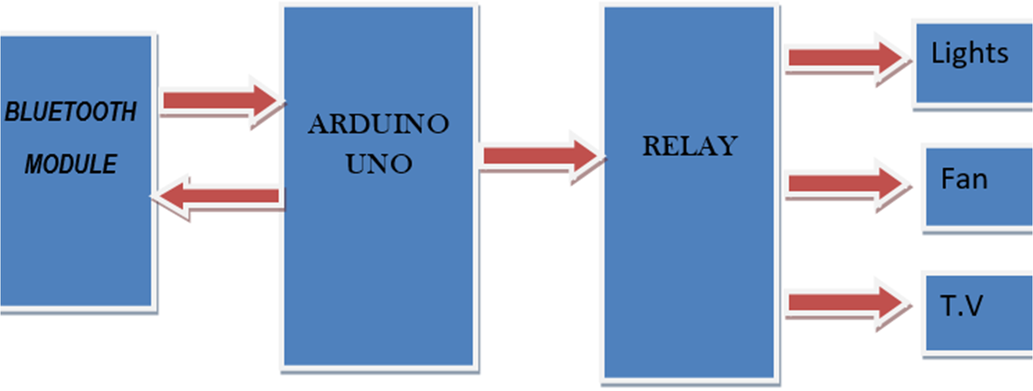
SCREENSHOTS

